Modern Method Software Engineering
Home work 4
Shanbo Li | 840810-A478 | shanboli@Gmail.com | 0704646157
Sike Huang | 850414-A394 | sike.huang@gmail.com | 0762320173

2007-10-07

Question 1: Consider the classification of Design goals (given in Section 6.4.2). Assign one or more categories of design goals to each of following goals.

1. User must be given feedback within one second after they issue any command.
Answer:
Response time (Performance)

2. The ticketdistributor must be able to issue train tickets, even in the event of network failure.
Answer:
Fault tolerance (Dependability)

3. The housing of ticketdistributor must allow for new buttons to be installed in case the enumber of fares increases.
Answer:
Extensibility (Maintance)

4. The atm must withstand dictionary attacks (i.e. users attempting to discover an identification number by systematic trials).
Answer:
Security (Dependability)

Question 3: Consider Repository, Model/View/Controller, Client-Server, Peer-to-Peer, n-Tier, and ‘Pipe and filter’ architectural styles (Section 6.3.5). Discuss how these architectures affect the following design goals. I) Extensibility II) Response Time III) Modifiability IV) Access Control V) Maintenance cost VI) Adaptability.

1. Consider a concrete example first (preferably a single example) and then try to decompose into above mentioned architectural styles. And then discuss how architecture affects the mentioned design goals. (Use bullets against each design goal, better create a table comparing architectures with respect to design goals)
Answer:
Let’s consider developing a large-scale online game, such as World of Warcraft. First of all, we decompose the whole game into some subsystems, where each subsystem utilizes certain design pattern philosophy.

Gaming data management system: data is crucially important in a game, and the data has to be kept in a unified manner, so repository architectural style is chosen. We set up a central repository, or rather a database to hold all users’ data as well as those data used to construct the scenarios and behaviors in the game.

Interactive graphical user interface: though the game itself is unique, the same data can form different view from user’s aspect, by using model-view-control architectural style, we are able to render various user views in respect of the gaming environment, and separate the domain model and controller infrastructure as well.

Between end user client and gaming server: it’s natural to have client-server architectural style, where every client communicates with a central gaming server to exchange data and messages. So the central gaming server acts as a master and leads the game.

Among end user clients: if one player is communicating with another player, it’s clumsy that every message is delivered and forwarded by server, in such case, the peer-to-peer architectural style will connect the player directly, and significantly relieve the server load.

Gaming system as a whole: a game such as World of Warcraft is very complex, and the software system to handle this complexity has to consider many things, one after another. The n-tier architectural style supports design based on increasing levels of abstraction, and it allows implementers to partition a complex problem into a sequence of incremental steps.

Events processors in virtual world: there are numerous events in a game, events can happen in any order at any time, the combination of events can be regarded as another event as well, under such condition, pipe and filter architectural style suits the best, we can define event processor like a filter, and set up event flow channel as a pipe, then it’s possible to deal with no matter what kinds of events.

 | Repository | MVC | CS
Extensibility | Moderate, new functionalities can be added to other subsystems based on accessing central repository. | Good, controller, model and view are independent from each other, easy to change. | Poor, it’s possible to add new functionalities in server, but it will affect the clients.
Response Time | Poor, central repository can soon become the bottleneck. | Moderate, controller takes care of all transactions, it may overload. | Poor, too many clients will dramatically decrease the performance.
Modifiability | Moderate, adding new services in the form of additional subsystems. | Good, easy to add new functionalities to controller. | Moderate, the update in server will propagate to its entire clients.
Access Control | Good, data can be strongly protected in the central repository. | Moderate, controller has to take care of security issues. | Good, actions are centralized in one place.
Maintenance cost | Low, since data is most important factor, central control of data is feasible. | Low, bugs usually lies in the controller. | Normal, server must be updated to balance the load.
Adaptability | Poor, different application has various data types to be handled. | Moderate, domain model can be changed. | Moderate, clients only need to know about the specific domain server.

 | P2P | n-Tier | Pipe&Filter
Extensibility | Poor, any changes has to be distributed. | Good, new functions are added to its corresponding tier. | Good, pipes can be added at run time.
Response Time | Fast, direct link between clients, no middleman. | Poor, elaboration of work. | Fast, all filters are processes that run at the same time.
Modifiability | Poor, any changes has to be distributed. | Good, changes in one tier only affect adjacent layers. | Good, filters are independent to each other.
Access Control | Poor, no central supervision. | Poor, control must be spread out through all tiers. | Poor, nothing prevents adding pipes or filters.
Maintenance | High, distributed problem is hard to find and solve. | Low, only one or few ties may have to fix. | Low, pipes and filters are flexible to fix.
Adaptability | Good, peer is not blind to certain application domain. | Good, ties can be adapted to different domain. | Good, domain independency.

2. Make sets of design goals (not just limited to above mentioned design goals, consult section 6.4.2) for each architectural style that could serve as guideline for choosing certain system architecture.
Answer:
Repository: Robustness, Reliability, Availability, Security, Administration cost
Mode/View/Controller: Maintenance cost, Extensibility, Modifiability, Portabilit
Client-Server: Adaptability, Maintenance cost, Update cost
Peer-to-Peer: Memory, Fault tolerance,
n-Tier: Modifiability, Adapterbility, Portability
Pipe and Filter: Extensibility, Modifiability, Readability, Throughput

Question 5: List the factors due to which you can’t describe boundary use-cases in Requirements elicitation or Requirement Analysis phase?

Answer:
It is normal that boundary use cases are not described during requirement elicitation/analysis, or rather they are considered separately from the common use cases. For example, many system administration functions, such as registering and deleting users, managing access control, can be derived from the daily user requirements, whilst, many other functions are consequences of design decisions, say, cache sizes, location of database/backup servers, which are not of requirement decisions.

Question 7: What design pattern(s) will you use if you are supposed to realize following commands in your own developed UNIX shell:

$ cat apple.txt | wc | mail -s "The count" nobody@december.com

Answer:

Question 9: Develop a recursive composite design pattern and represent it using UML Class diagram. (Bonus Point 02)

Answer:
The intent of recursive composite design pattern is to compose objects into tree structures to present part-whole hierarchies, and treat individual objects and compositions of objects uniformly.
An obvious and concrete example is how the files and directories are treated in the operation systems:
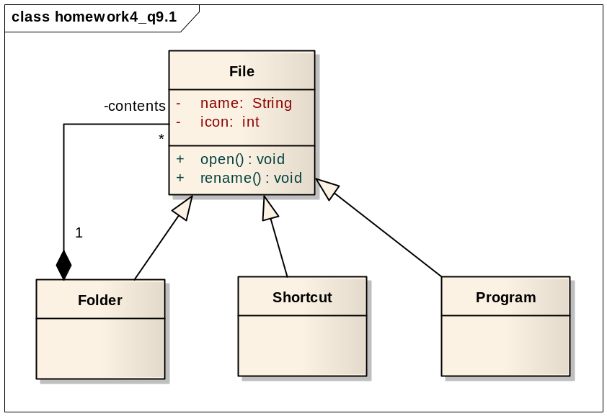
We can abstract the idea above into the recursive composite design pattern depicted in the UML class diagram below:
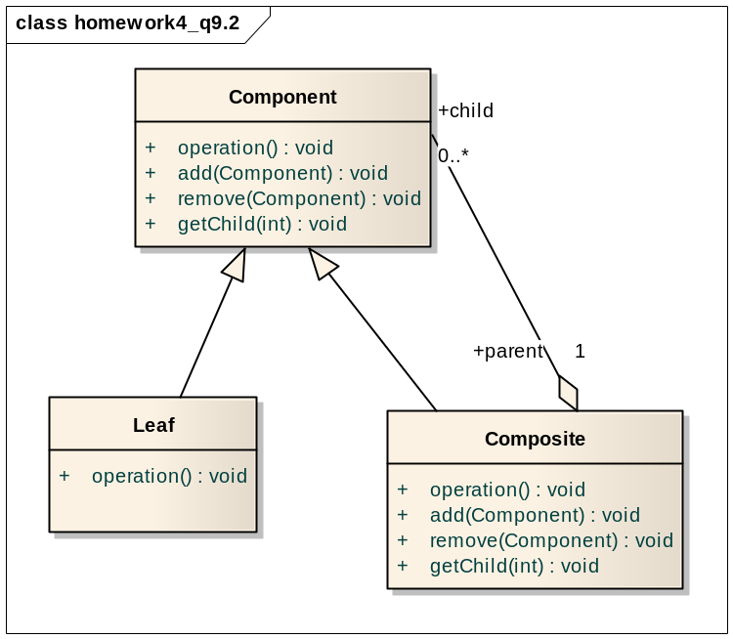
Component is the abstraction for all components, including composite ones, it declares the interface for objects in the composition and implements default behavior for the interface common to all classes, as appropriate.
Leaf represents leaf objects in the composition and implements all Component methods.
Composite represents a composite Component i.e. component having children, and implements methods to manipulate children.

Question 11: Consider a simple intersection with two crossing roads and four traffic lights. Assume a simple algorithm for switching lights, so that the traffic on one road can proceed while the traffic on the other road is stopped. Model each traffic light as an instance of a TrafficLight class with a state attribute that can be red, yellow, or green. Write invariants in OCL on the state attribute of the TrafficLight class that guarantee that the traffic cannot proceed on both roads simultaneously. Add associations to the model to navigate the system, if necessary. Note that OCL constraints are written on classes (as opposed to instances).

